**API Documentation**

1. **GET Method (GET All Customer Records)**

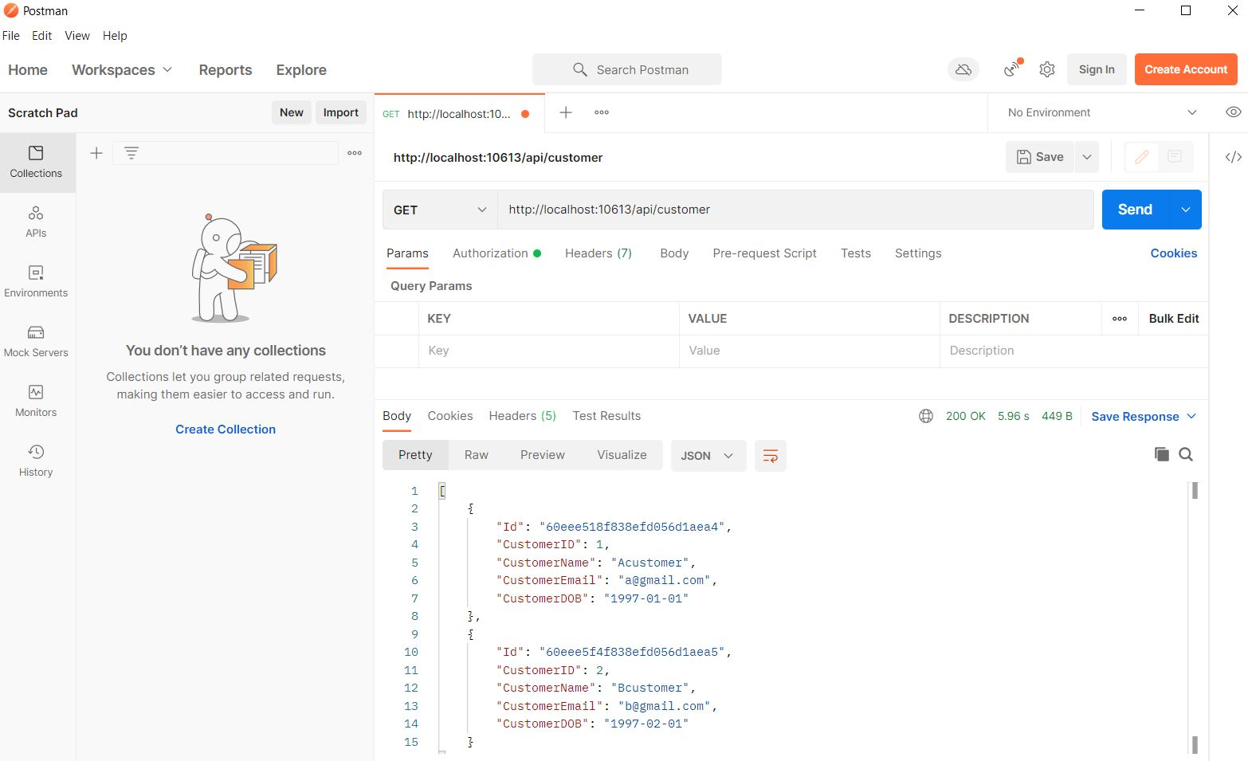

1. **POST Method (Add New Customer Records)**

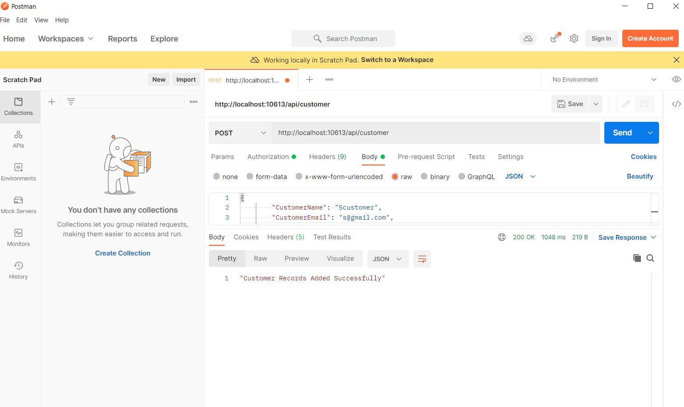

1. **PUT Method (Update Customer Records)**

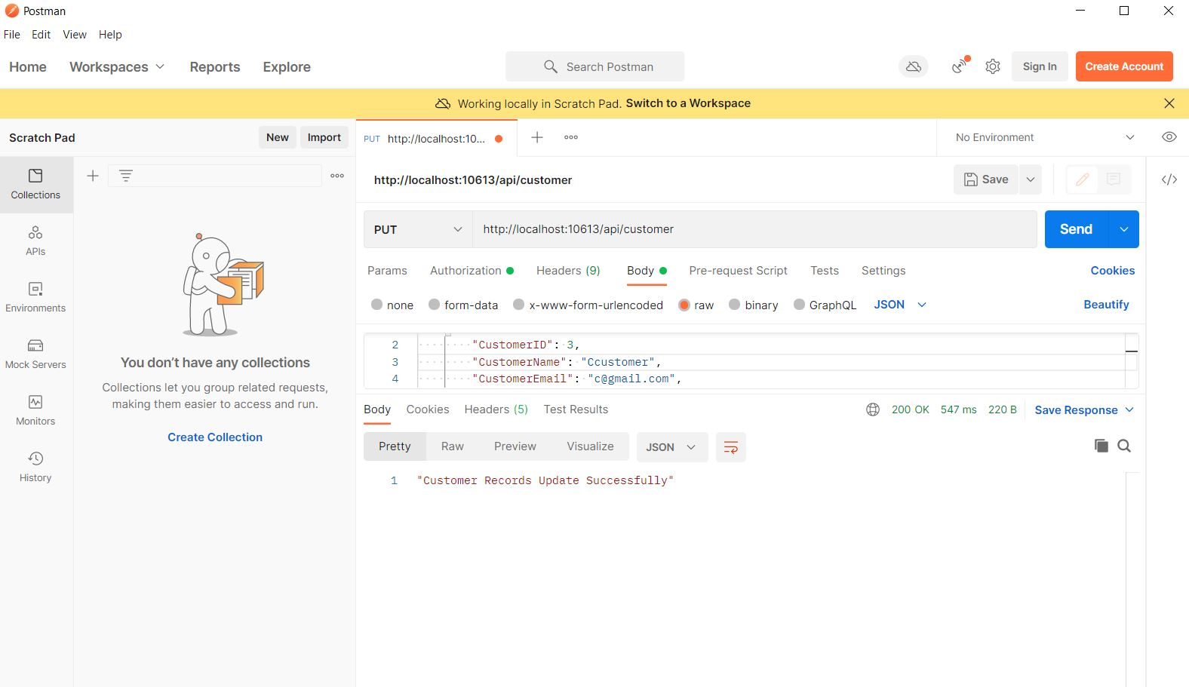

1. **DELETE Method (Delete Customer Records)**

